**Wiki species Page Rank**

I edited the code to iterate 250 times to check when the page rank deltas where converging.

The loop code is added to SpeciesIterDriver2.java as shown below:

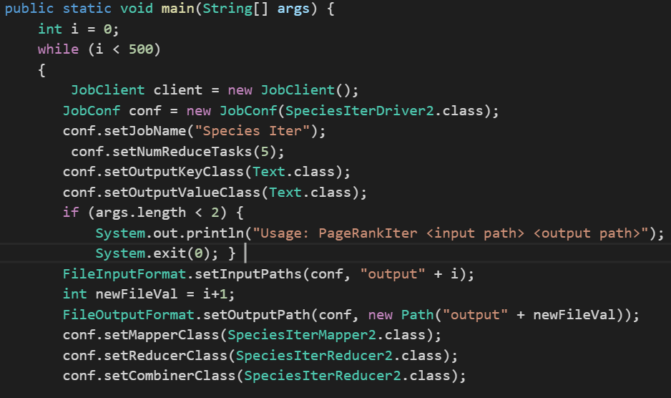

However, I also executed the code by changing the damping factor to 0.85 and observed that it was converging faster in this case.

Below is the graph which shows that the page rank for the species dataset starts converging after some iterations.

The output files are placed in the output folder with separate folders for each iteration.

The same sequence of execution was performed on pseudo distributed mode as well. The output and screenshots for that execution is added in separate folders.

**Pseudo-Distributed**

To run the code in pseudo distributed environment, firstly I changed the config files to add the settings for pseudo-distributed environment, then executed the following commands to start the daemons:

* bin/hadoop namenode -format
* bin/start-all.sh
* bin/hadoop datanode
* bin/hadoop tasktracker

Quick jsp command shows me that my namenode, datanode, jobtracker and tasktracker are running.

After the daemons are up and running, I executed the following commands to run the graph builder.

* bin/hadoop fs -put input input_species
* bin/hadoop jar speciesgraphbuilder.jar U.CC.SpeciesGraphBuilder input_species output0

I executed the following commands to run the iterator.

* bin/hadoop jar speciesiterator_classes.jar U.CC.SpeciesIterDriver2 output0 output_species2

and similarly for viewer.

Screenshots are placed in the separate folder as well.